FRONT-END INTERN

AN INTERNSHIP REPORT
Submitted by
ADITYA KULKARNI - 20221CSG0013
Under the guidance of,
Dr. Poornima S

BACHELOR OF TECHNOLOGY

IN
COMPUTER SCIENCE AND TECHNOLOGY
(ARTIFICIAL INTELLIGENCE AND MACHINE LEARNING)


PRESIDENCY UNIVERSITY BENGALURU APRIL 2026

PRESIDENCY SCHOOL OF COMPUTER SCIENCE AND ENGINEERING
BONAFIDE CERTIFICATE

Certified that this report Front-End Intern is a bonafide work of Aditya Kulkarni (20221CSG0013), who has successfully carried out the internship work and submitted the report for partial fulfilment of the requirements for the award of the degree of BACHELOR OF TECHNOLOGY in COMPUTER SCIENCE AND TECHNOLOGY (Artificial
Intelligence and Machine Learning), during 2025-2026.

Dr Poornima S
Assistant Professor (Senior Scale)
Internship Guide PSCS
Presidency University

Mr. Saptarsi Sanyal
Associate Professor
Program Internship Coordinator PSCS
Presidency University

Dr. Md Ziaur Rahaman
Associate Professor
School Internship Coordinator PSCS
Presidency University

Dr. Pallavi R
Professor & Head of the Department PSCS
Presidency University

Dr. Duraipandian N
Dean PSCS
Presidency University

Name and Signature of the Examiners

Sl.No | Name of the Examiner | Signature

PRESIDENCY UNIVERSITY PRESIDENCY SCHOOL OF COMPUTER SCIENCE AND
ENGINEERING
DECLARATION
I am a student of final year B.Tech in COMPUTER SCIENCE AND TECHNOLOGY (Artificial Intelligence and Machine Learning), at Presidency University, Bengaluru, named Aditya Kulkarni, hereby declare that the internship work titled Front-End Intern has been independently carried out by me and submitted in partial fulfillment for the award of the degree of B.Tech in COMPUTER SCIENCE TECHNOLOGY (Artificial Intelligence and Machine Learning) during the academic year of 2025-2026. Further, the matter embodied in the internship has not been submitted previously by anybody for the award of any Degree or Diploma to any other institution.

Aditya Kulkarni USN: 20221CSG0013 Signature

PLACE: BENGALURU DATE: 24 - April 2026

INTERNSHIP COMPLETION CERTIFICATE

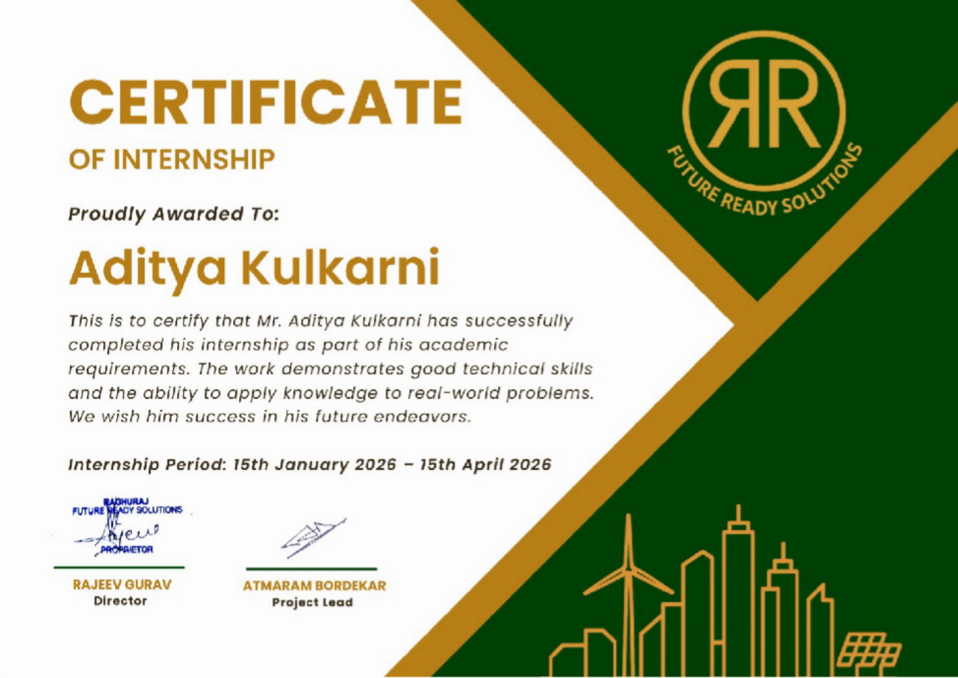

ACKNOWLEDGEMENT
For completing this internship work, I have received the support and the guidance from many people whom I would like to mention with deep sense of gratitude and indebtedness. I extend my gratitude to our beloved Chancellor, Pro-Vice Chancellor, and Registrar for their support and encouragement in completion of the internship.
I would like to sincerely thank my internal guide Dr. Poornima S, Assistant Professor, Presidency School of Computer Science and Engineering, Presidency University, for her moral support, motivation, timely guidance and encouragement provided to me during the period of internship work.
I am also thankful to Dr. Pallavi R, Professor, Head of the Department, Presidency School of Computer Science and Engineering, Presidency University, for her mentorship and encouragement. I express my cordial thanks to Dr. Duraipandian N, Dean PSCS & PSIS and the Management of Presidency University for providing the required facilities and intellectually stimulating environment that aided in the completion of my internship work.
I am grateful to Dr. Md Ziaur Rahaman, Internship Coordinator and Mr. Saptarsi Sanyal Program Internship Coordinator, Presidency School of Computer Science and Engineering, or facilitating problem statements, coordinating reviews, monitoring progress, and providing their valuable support and guidance.
I am also grateful to Teaching and Non-Teaching staff of Presidency School of Computer Science and Engineering and also staff from other departments who have extended their valuable help and cooperation.
Aditya Kulkarni

ABSTRACT
This report presents the work carried out during a three-month internship as a Frontend Developer Intern at Raghuraj, an emerging startup focused on sustainable energy solutions such as solar panels, EV charging systems, and water treatment infrastructure. The primary objective of the internship was to contribute to the development of a modern, responsive web interface that enhances the company’s digital presence and improves user interaction.

The project involved the design and implementation of a frontend system using React.js, following a component-based architecture. The application was developed as a Single Page Application (SPA), enabling dynamic content rendering and seamless navigation without page reloads. Key tasks included developing reusable UI components, implementing responsive layouts using CSS techniques such as Flexbox and Grid, and ensuring design consistency based on Figma prototypes.
In addition to UI development, the internship provided exposure to API integration, allowing the frontend to communicate with backend services for dynamic data handling. A chat interface was also developed at the UI level to support future AI-based interaction, although the complete chatbot logic was handled separately.

The development process followed an iterative and flexible workflow suitable for a startup environment, where requirements evolved over time. Challenges such as managing responsiveness, understanding React concepts, and debugging UI issues were addressed through continuous learning and practical implementation.

The project successfully resulted in a functional and responsive frontend prototype capable of presenting the company’s services and products in a structured manner. The experience provided valuable insights into modern web development practices, component-based design, and real-world collaboration. The work serves as a foundation for further development, including backend integration, performance optimization, and deployment.

 | TABLE OF CONTENTS
Sl. No. | Title | Page
 |  | No.
 | Declaration | iii
 | Acknowledgement | v
 | Abstract | vi
 | List of Figures | x
 | List of Tables | xi
 | Abbreviations | xii
1. | Introduction | 1
 | 1.1 Background | 1
 | 1.2 Statistics of Internship | 3
 | 1.3 Prior existing technologies | 3
 | 1.4 Proposed approach | 4
 | 1.5 Objectives | 5
 | 1.6 SDGs | 6
 | 1.7 Overview of internship report | 6
2. | Literature Review | 8
3. | Methodology | 14
4. | Project Management | 23
 | 4.1 Internship timeline | 23
 | 4.2 Risk analysis | 25
 | 4.3 Internship budget | 26
 | 4.4 Summary of Project Management | 27
5. | Analysis and Design | 29
 | 5.1 Requirements | 29
 | 5.2 Block Diagram | 30
 | 5.3 System Flow Chart | 31
 | 5.4 Choosing devices (Adapted for Web System) | 32
 | 5.5 Designing units | 32
 | 5.6 Standards | 33
 | 5.7 Mapping with IoTWF reference model layers (Adapted) | 34
 | 5.8 Domain model specification | 35

  - Communication model 35
  - Deployment level (Adapted) 36
  - Functional view 36
  - Mapping Deployment with Functional View 37
  - Operational view 37
  - Other Design Aspects 37
- Hardware, Software and Simulation 39
  - Introduction 39
  - Hardware Requirements 39
  - Software Requirements 40
  - System Implementation 41
  - Sample Code Representation 42
  - Simulation and Testing 44
  - Limitations of Implementation 45
  - Summary 45
- Evaluation and Results 46
  - Introduction 46
  - Evaluation Objectives 46
  - Evaluation Criteria 46
  - Testing Strategy 47
  - Test Results 48
  - Observations 48
  - Performance Analysis 48
  - Learning Outcomes 49
  - Challenges and How They Were Addressed 50
  - Limitations of Project 50
  - Key Insights 51
  - Summary of Results 51
- Social, Legal, Ethical, Sustainability and Safety Aspects 52
  - Introduction 52
  - Social Aspects 52
  - Legal aspects 53
  - Ethical aspects 54
  - Sustainability aspects 55
  - Safety Aspects 56
  - Summary 57
- Conclusion 58
  - Conclusion 58
  - Future Scope 59
  - Final Remarks 61
References 62
Appendix - A 64
Appendix - B 65
Appendix - C 66

Sl. No. | Figure Name | Caption | Page No.
1 | Figure 1 | Development Workflow | 16
2 | Figure 2 | Feature Development Process | 21
3 | Figure 3 | Functional Block Diagram | 30
4 | Figure 4 | System Flow Chart | 31
5 | Figure 5 | Unit Interaction Diagram | 33
6 | Figure 6 | Domain Model Specification | 35
7 | Figure 7 | Communication Model | 36
8 | Figure 8 | Functional View | 37

Sl. No. | Table Name | Table Caption | Page No.
1 | Table 2.1 | Summary of Literature Review | 12
2 | Table 3.1 | SDLC Phases | 15
3 | Table 4.1 | Project Planning Timeline | 23
4 | Table 4.2 | Project Implementation Timeline | 24
5 | Table 4.3 | PESTLE Analysis for the Project | 25
6 | Table 4.4 | Risk Matrix | 26
7 | Table 4.5 | Project Budget Estimation | 27
8 | Table 5.1 | System Requirements | 29
9 | Table 5.2 | Tool Comparison | 32
10 | Table 5.3 | IoTWF Mapping | 34
11 | Table 6.1 | Hardware Specifications | 39
12 | Table 6.2 | Development Tools | 40
13 | Table 6.3 | Frontend Technologies | 40
14 | Table 6.4 | Design Tools | 41
15 | Table 6.5 | Backend Tools | 41
16 | Table 6.6 | Test Cases | 44
17 | Table 7.1 | Test Results Summary | 48

Abbreviation | Full Form
SPA | Single Page Application
UI | User Interface
UX | User Experience
HTML | HyperText Markup Language
CSS | Cascading Style Sheets
JS | JavaScript
API | Application Programming Interface
DOM | Document Object Model
JSON | JavaScript Object Notation
SDLC | Software Development Life Cycle
AI | Artificial Intelligence
RAG | Retrieval-Augmented Generation

Chapter 1

Introduction

Background
The global transition toward sustainable and renewable energy has accelerated significantly over the past decade. Increasing concerns regarding climate change, carbon emissions, and energy security have driven governments and industries to adopt environmentally responsible technologies. According to the International Energy Agency, renewable energy sources such as solar and wind power are among the fastest-growing segments in global energy production.
In parallel with this shift, digital transformation has become a critical requirement for businesses operating in technical and service-oriented domains. A strong digital presence enables organizations to communicate their offerings effectively, improve customer engagement, and scale their operations. Research by Statista indicates that a majority of consumers rely on online platforms to explore products and services before making purchasing decisions.
Raghuraj is an emerging startup operating in the sustainable energy and infrastructure sector, with operations in Goa and Mumbai. The company provides installation and support services for technologies such as solar panels, mini wind turbines, EV charging systems, water treatment plants, and heat pumps. As a growing organization, Raghuraj primarily focuses on service delivery and project execution, with limited emphasis on digital infrastructure in its early stages.
Due to this, the company faces challenges in effectively showcasing its products, communicating technical details, and handling customer queries efficiently through digital means. Traditional communication channels such as phone calls and direct interactions dominate, which limits scalability.
This internship was undertaken to contribute to the early-stage digital transformation of the company by developing a modern, responsive web platform. The project focuses on improving accessibility, enhancing user experience, and preparing the foundation for future features such as AI-assisted customer support.

The internship was carried out over a period of three months as part of the academic curriculum under the CSE7302 Internship program. It provided an opportunity to gain practical exposure to real-world software development practices in a startup environment.

Internship Details:

Role: Front-End Developer Intern

Duration: 3 months

Domain: Web Development and Front-End Engineering

Organization Type: Early-stage startup

Work Structure: Flexible, team-based collaboration

Technologies and Tools Used:

Frontend Technologies:

HTML5 CSS3
JavaScript (ES6+) React

Framework Exposure:

Next.js (basic exposure and learning)

Design Tools:

Figma

Backend Exposure:

Basic understanding of APIs Exposure to FastAPI-based systems
Awareness of Retrieval-Augmented Generation (RAG) concepts

Version Control:

Git and GitHub

During the internship, the primary responsibility involved developing frontend components and user interfaces using React. In addition to this, there was limited but meaningful exposure to backend workflows and AI-based system concepts through collaboration and observation.

Statistics of Internship
The front-end internship was conducted over a duration of 3 months, involving consistent participation in a flexible and collaborative team environment. The average working time was approximately 5–6 hours per day, resulting in an estimated total of 400–450 hours of practical experience.
The distribution of work carried out during the internship is as follows:

    - UI Development and React Component Design: 50%

    - API Integration and Data Handling: 15%

    - Debugging and Performance Optimization: 15%

    - Testing and Responsiveness: 10%

    - Learning and Research (Next.js, RAG concepts, backend exposure): 10%

The majority of the time was dedicated to developing interactive and responsive user interfaces using React, while also gaining exposure to backend systems and modern AI-integrated workflows through collaborative development.

Prior Existing Technologies
In many early-stage startups, especially those focused on engineering and infrastructure services, digital platforms are often not prioritized during initial phases. Instead, operations rely heavily on manual communication and offline processes.

Characteristics of Prior Systems Limited or Basic Web Presence
Static informational pages or no dedicated platform Lack of structured product catalogue

Manual Customer Interaction

Communication through phone calls and messaging platforms No automated support systems

Lack of Technical Visualization

Complex product details not presented in an accessible format Difficulty for customers to understand offerings

Non-Scalable Communication

Increased workload with growing customer base Inefficiency in handling multiple queries
According to usability research by Nielsen Norman Group, users tend to disengage quickly from systems that lack clarity, responsiveness, and intuitive navigation. This highlights the importance of structured and user-friendly digital platforms.
Additionally, traditional web development approaches lack modularity and scalability when compared to modern frameworks such as React, which enable component-based development and improved performance.

Proposed Approach
To address the limitations identified in the existing system, a modern web-based solution was proposed and partially implemented during the internship.
Key Features of the Proposed System Frontend Development using React Development of a Single Page Application (SPA) Component-based architecture for reusability Responsive User Interface
Mobile-first design approach

Compatibility across different screen sizes

Structured Product Presentation

Organized display of services and technologies Improved readability and navigation

Basic API Integration

Fetching and displaying dynamic data Understanding client-server interaction

Chatbot Interface (Frontend Implementation)

Development of a chat UI component

Prepared for integration with backend AI systems

Exposure to AI-Based System Concepts

Understanding of Retrieval-Augmented Generation (RAG)

Preparation of structured data (such as PDF-based knowledge inputs) for AI usage Awareness of how AI systems process and retrieve information

Scalable Foundation

Designed with future expansion in mind

Supports integration with backend services and AI systems

It is important to note that the system developed during the internship is at a functional and developmental stage, with several advanced features planned for future implementation.

Objectives
The objectives of the internship were aligned with both technical development and learning outcomes.

Technical Objectives

To design and implement a responsive web interface using React To develop reusable UI components

To integrate frontend components with APIs

To build a functional chat interface for future AI integration

Learning Objectives

To gain practical experience in modern frontend development To understand the basics of backend systems and API workflows To explore concepts related to AI-assisted applications
To improve debugging and problem-solving skills

Organizational Objectives

To contribute to the digital presence of a growing startup To improve accessibility of technical product information To support scalable customer interaction mechanisms

Sustainable Development Goals (SDGs)
The internship project aligns with several Sustainable Development Goals defined by the United Nations.

SDG 7: Affordable and Clean Energy

The platform promotes technologies such as solar panels and EV charging systems.

SDG 9: Industry, Innovation, and Infrastructure

The project supports innovation by integrating digital solutions into infrastructure services.

SDG 13: Climate Action

By encouraging sustainable practices, the project contributes to environmental protection.

Overview of Internship Report
This report is structured to provide a detailed understanding of the internship work:

Chapter 1: Introduction Chapter 2: Literature Review Chapter 3: Methodology Chapter 4: Project Management Chapter 5: Analysis and Design
Chapter 6: Hardware, Software and Simulation

Chapter 7: Evaluation and Results

Chapter 8: Social, Legal, Ethical, Sustainability and Safety Aspects

Chapter 9: Conclusion APPENDIX—A, B, C

Chapter 2

Literature Review

Introduction
The development of modern web applications, especially in startup environments, requires the integration of scalable frontend technologies, efficient user interface design, and intelligent backend systems. This literature review examines relevant research in frontend frameworks, user experience design, component-based architectures, and AI-assisted systems such as chatbots.
The objective of this review is to identify existing approaches, understand their limitations, and position the current project within this technological landscape.

Review of Existing Literature
Literature 1: Component-Based UI Development using React
A study by Facebook Engineering (React Core Team) introduced React as a declarative and component-based JavaScript library designed for building scalable user interfaces. The approach emphasizes dividing the interface into reusable components, improving maintainability and performance through the use of a virtual DOM.
The results demonstrated improved rendering efficiency and simplified UI management in large-scale applications. However, the study also highlighted the steep learning curve associated with concepts such as state management and lifecycle methods. This is particularly relevant in a learning environment where developers require time to adapt to these abstractions.
A limitation observed is that React alone does not provide a complete framework, requiring additional libraries for routing and state management. This creates complexity for beginners.

Literature 2: Single Page Applications and Performance Optimization

Research on Single Page Applications (SPAs) shows that they significantly enhance user experience by eliminating full page reloads and enabling dynamic content updates. SPAs rely heavily on client-side rendering, which improves responsiveness and reduces server load.
The findings suggest that SPAs are particularly effective for applications requiring high interactivity. However, they also introduce challenges such as increased initial loading time and potential SEO limitations.
For startup-level applications, SPAs offer a balance between performance and development simplicity, although optimization strategies must be carefully implemented.

Literature 3: Responsive Web Design Principles
Responsive web design has been widely studied as a fundamental requirement for modern applications. Research emphasizes the use of flexible layouts, media queries, and adaptive components to ensure usability across different devices.
The results indicate that responsive design significantly improves user engagement and accessibility. However, challenges arise in maintaining consistency across various screen sizes, especially when dealing with complex layouts.
This aligns with practical challenges faced during implementation, particularly in handling CSS responsiveness.

Literature 4: UI/UX Design and User Engagement
Studies in user experience design highlight that usability, visual hierarchy, and intuitive navigation are critical factors influencing user satisfaction. Poor UI design can lead to increased bounce rates and reduced interaction.
The research shows that tools like Figma facilitate collaborative design and improve the accuracy of design-to-code translation. However, discrepancies often occur during implementation due to differences between design prototypes and actual development constraints.

This gap emphasizes the importance of continuous iteration between design and development teams.

Literature 5: API-Based Client-Server Communication
Modern web applications rely on RESTful APIs for communication between frontend and backend systems. Research indicates that APIs enable modular system design and allow independent development of frontend and backend components.
The results demonstrate improved scalability and flexibility. However, improper API handling can lead to latency issues and inconsistent data rendering.
For frontend developers, understanding API interaction is essential, even when backend implementation is not directly handled.

Literature 6: Agile Development in Startup Environments
Agile methodologies have been widely adopted in software development due to their flexibility and iterative nature. Research shows that startups particularly benefit from Agile practices due to rapidly changing requirements and limited resources.
The findings indicate improved adaptability and faster development cycles. However, the lack of structured processes in some startups can lead to inefficiencies and unclear task allocation.
This aligns with the flexible workflow observed during the internship.

Literature 7: Chatbots in Web Applications
Chatbots have become an integral part of modern web applications, providing automated customer support and improving user interaction. Research shows that chatbots reduce response time and enhance user satisfaction.
However, traditional rule-based chatbots are limited in handling complex queries. This has led to the development of AI-based systems that can generate more context-aware responses.
The limitation remains in ensuring accuracy and avoiding incorrect responses.

Literature 8: Retrieval-Augmented Generation (RAG)
Recent advancements in AI have introduced Retrieval-Augmented Generation (RAG) as a method to improve the reliability of chatbot responses. RAG combines information retrieval from structured data sources with natural language generation.
The results indicate that RAG significantly reduces incorrect or “hallucinated” responses by grounding outputs in actual data. However, implementing such systems requires proper data structuring and integration with backend services.
For an intern-level contribution, exposure to this concept provides valuable insight into modern AI systems.

Literature 9: Version Control and Collaborative Development
Version control systems such as Git have been extensively studied as essential tools in collaborative software development. They enable tracking changes, managing code versions, and facilitating teamwork.
Research highlights that proper use of branching and version control improves project stability and reduces conflicts. However, beginners often face challenges in understanding workflows such as merging and conflict resolution.

Literature 10: Digital Transformation in Small and Medium Enterprises
Digital transformation is a critical factor for the growth of small and medium enterprises (SMEs). Studies indicate that adopting digital platforms improves customer reach, operational efficiency, and scalability.
However, startups often face constraints such as limited resources, lack of technical expertise, and absence of structured digital systems. This creates a need for simple, scalable, and cost- effective solutions.
The current project directly addresses this gap by providing a foundational digital platform.

Summary of Literature Reviewed
Table 2.1 Summary of Literature Review

Literature Area | Key Contribution | Limitation | Relevance to Project
React | Component-based UI | Learning curve | Used for frontend
SPA | Improved UX | Initial load time | Used in system
Responsive Design | Device compatibility | Layout complexity | Implemented
UI/UX | Better engagement | Design-dev gap | Applied
APIs | Modular systems | Latency issues | Used
Agile | Flexible development | Lack of structure | Observed
Chatbots | Automated support | Limited accuracy | Implemented (UI)
RAG | Accurate AI responses | Complex setup | Exposure
Git | Collaboration | Learning difficulty | Used
Digital Transformation | Scalability | Resource constraints | Core motivation

Research Gaps Identified
From the literature review, several gaps have been identified:

Many systems focus on large-scale enterprise solutions, not startup-level implementations Limited research on simple, scalable digital platforms for small businesses

Gap between UI design and real-world implementation Challenges in integrating AI systems with frontend interfaces Lack of emphasis on learning-oriented development environments

Summary
The literature review highlights the importance of modern frontend frameworks, responsive design, and scalable architectures in building effective web applications. It also emphasizes the growing role of AI in enhancing user interaction.
The identified gaps justify the need for a practical implementation that focuses on simplicity, scalability, and usability within a startup environment. These insights form the foundation for the methodology and system design discussed in subsequent chapters.

Chapter 3

METHODOLOGY

Introduction
The methodology adopted during the internship was designed to balance structured learning with practical implementation in a real-world startup environment. Since the organization was in an early stage of digital transformation, the development process followed a flexible and iterative workflow rather than a rigid, predefined structure.
The approach focused on gradually understanding technologies, applying them to real tasks, and refining the implementation through continuous feedback and debugging. The methodology emphasizes learning, collaboration, and incremental development.

Selection of Methodology
In software development, several methodologies such as Waterfall, V-model, Agile, and DevOps are commonly used. For this internship, an Agile-based iterative development approach was most suitable.
Why Agile Methodology Was Chosen

The startup environment required flexibility and adaptability Requirements evolved over time
Continuous feedback was available from team members Development and learning occurred simultaneously
Unlike traditional models such as Waterfall, which require fixed requirements, Agile supports incremental progress and iterative improvements.

Agile Methodology Overview
Agile development follows an iterative cycle where features are developed, tested, and refined in multiple stages.

Key Phases in Agile:

Requirement understanding Design
Implementation Testing
Feedback and iteration Adaptation in Internship Context No strict sprint cycles
Tasks assigned dynamically

Frequent informal discussions instead of structured meetings

Mapping Internship Work to SDLC Phases
The internship activities can be mapped to standard Software Development Life Cycle (SDLC) phases as follows:

Table 3.1 SDLC Phases

SDLC Phase | Internship Activity
Requirement Analysis | Understanding company needs and product structure
System Design | Studying UI/UX designs (Figma)
Implementation | Developing React components
Testing | Debugging UI and responsiveness
Integration | Connecting frontend with APIs
Maintenance | Iterative improvements
This mapping ensures that the work follows a structured engineering process, even within a flexible startup environment.

Overall Development Workflow
The overall workflow followed during the internship is illustrated below.
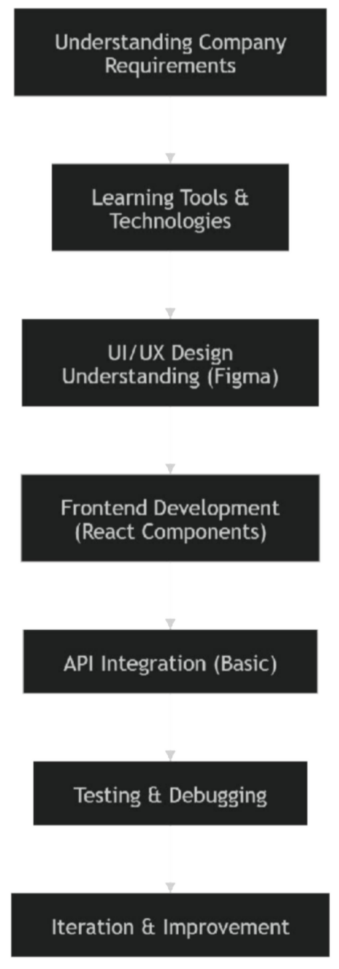

Figure 1 Development Workflow

This workflow represents the iterative nature of development, where continuous improvements were made based on feedback and testing.

Work Carried Out During Internship
The work carried out during the internship primarily focused on frontend development, with additional exposure to backend systems and AI-based application concepts. All tasks were performed under guidance and within a collaborative team environment.

Training and Learning Phase

The initial phase of the internship involved learning the required technologies and tools. Learning Areas:
React fundamentals:

Components and JSX Props and state
Hooks (useState, useEffect) Basic exposure to Next.js:
Understanding its purpose Differences from React UI/UX concepts:
Layout structuring Design consistency Version control:
Git basics

This phase was essential in building the technical foundation required for implementation.

Frontend Development

The core responsibility during the internship was frontend development using React. Tasks Performed:
Developing reusable UI components:

Navigation bar

Product display sections Footer
Structuring layouts:

Using CSS (Flexbox, Grid) Implementing responsive design:
Adapting UI for multiple devices Maintaining UI consistency:
Following Figma design references

The implementation focused on modular and maintainable code.

Chat Interface Development

A specific contribution involved developing the frontend interface for a chatbot. Work Done:
Designed chat UI layout

Implemented message display structure Prepared interface for backend integration
The chatbot logic and AI processing were handled separately, and the contribution was limited to the UI layer.

API Integration and Backend Exposure

Although the primary role was frontend-focused, there was exposure to backend workflows. Activities Included:
Understanding API requests and responses Integrating frontend with backend endpoints Handling dynamic data rendering
Additionally, there was conceptual exposure to:

FastAPI-based backend systems Data flow between components

Exposure to AI-Based Systems

The internship included limited exposure to AI-based systems, particularly chatbot implementation.
Key Exposure:

Understanding Retrieval-Augmented Generation (RAG) Preparing structured data (PDF-based information) Observing how AI responses are generated
This exposure provided insight into how AI systems can enhance web applications.

Debugging and Problem Solving

Debugging was an important part of the development process. Challenges Faced:
React-related issues

CSS responsiveness problems

UI inconsistencies Approach:
Using browser developer tools Iterative testing and fixing Referring to documentation

Collaboration and Workflow

The internship involved working in a collaborative environment. Key Aspects:
Interaction with frontend and backend teams Working with design references
Adapting to feedback

Due to the startup environment:

Workflow was flexible Meetings were informal Tasks evolved dynamically

Feature Development Process
The step-by-step process for implementing features is shown below:

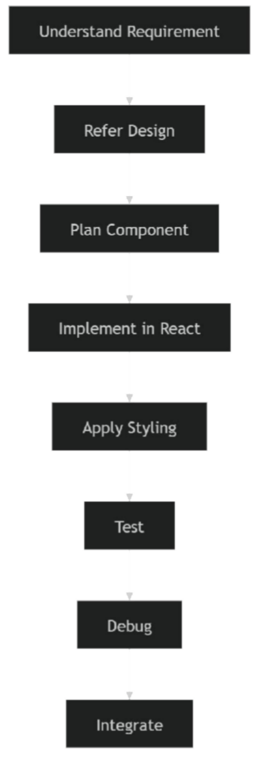
Figure 2 Feature Development Process

Challenges in Methodology Execution
The methodology presented several challenges: Learning complex React concepts

Handling responsive design issues Balancing learning and implementation Adapting to unstructured workflow
These challenges were gradually addressed through practice and guidance.

Improvements Over Time
Over the course of the internship:

Improved understanding of React Better handling of UI layouts Increased debugging efficiency
Improved adaptability to team workflows

Summary of Methodology
The methodology adopted during the internship effectively combined Agile principles with practical learning. The flexible and iterative approach allowed gradual improvement while contributing to the development of the project.
Key highlights include:

Use of Agile-inspired workflow Strong focus on frontend development Exposure to backend and AI concepts Continuous testing and improvement Real-world collaborative experience

Chapter 4

Project Management

Internship Timeline
Project management during the internship followed a flexible structure due to the startup nature of the organization. However, the work can be systematically represented using a timeline that reflects the planning and implementation phases.
The project was carried out over a duration of three months, during which activities progressed from learning and understanding to implementation and refinement.

    - Project Planning Timeline

Table 4.1 Project Planning Timeline

Phase | Task Description | Duration | Outcome
Week 1 | Understanding company domain and requirements | 1 week | Familiarity with products and services
Week 2 | Learning frontend technologies (React basics) | 1 week | Foundation in React
Week 3 | UI/UX design understanding (Figma) | 1 week | Design interpretation skills
Week 4 | Component planning and structuring | 1 week | Development roadmap

Description of Planning Phase

The planning phase focused on building a strong understanding of the project requirements and acquiring the necessary technical skills. Since the organization did not have a fully defined digital system, this phase also involved interpreting requirements and identifying suitable approaches for implementation.

This phase was essential in ensuring that development tasks were aligned with the company’s needs.

    - Project Implementation Timeline

Table 4.2 Project Implementation Timeline

Phase | Task Description | Duration | Outcome
Week 5–6 | Development of UI components (React) | 2 weeks | Functional UI elements
Week 7 | Responsive design implementation | 1 week | Device compatibility
Week 8 | Chat interface development | 1 week | Chat UI component
Week 9 | API integration (basic) | 1 week | Dynamic data handling
Week 10 | Debugging and testing | 1 week | Improved stability
Week 11–12 | Refinement and optimization | 2 weeks | Enhanced performance

Description of Implementation Phase

The implementation phase involved translating design concepts into functional code. Tasks were carried out incrementally, with continuous testing and refinement.
Due to the startup environment:

Tasks were flexible Deadlines were adaptive
Work progressed based on priority

This approach allowed gradual improvement without strict constraints.

Suitability of Timeline

The timeline adopted was suitable for the project because:

It allowed progressive learning and implementation It adapted to changing requirements
It supported incremental development It aligned with Agile-based workflow

Risk Analysis
Risk analysis is an important aspect of project management, as it helps identify potential issues that may affect project success. For this project, a PESTLE analysis approach is used to evaluate risks.

    - PESTLE Analysis

Table 4.3 PESTLE Analysis for the Project

Factor | Risk Description | Impact | Mitigation
Political | Changes in energy regulations | Low | Focus on adaptable system
Economic | Budget constraints in startup | Medium | Use open-source tools
Social | Low digital adoption by users | Medium | Simple UI design
Technological | Rapid tech changes | Medium | Use scalable frameworks
Legal | Data privacy concerns | Low | Follow basic security practices
Environmental | Dependency on sustainability sector | Low | Align with eco-friendly goals

    - Project Risk Matrix

Table 4.4 Risk Matrix

Risk | Probability | Impact | Mitigation
React learning difficulty | High | Medium | Continuous practice
CSS responsiveness issues | High | Medium | Testing on multiple devices
Unclear requirements | Medium | Medium | Frequent clarification
Integration challenges | Medium | Medium | Incremental testing
Time management | Medium | Medium | Task prioritization

Risk Discussion

The major risks identified were primarily technical and process-related. Learning React and handling responsive design posed initial challenges. Additionally, the flexible nature of the startup environment led to occasional ambiguity in requirements.
These risks were mitigated through:

Continuous learning Iterative testing
Seeking guidance when required

Internship Budget
Since the project was carried out as part of an internship in a startup environment, the budget was minimal and primarily consisted of existing resources.

    - Budget Estimation

Table 4.5 Project Budget Estimation

Resource | Description | Cost
Hardware | Personal laptop | Already available
Software | React, Node.js, VS Code | Free (open-source)
Design Tool | Figma (basic version) | Free
Internet | Required for development | Existing
Hosting | Not deployed / optional | Minimal

Budget Description

The project required minimal financial investment due to the use of open-source technologies. Most tools used during development were freely available, making the solution cost-effective.
This is particularly suitable for startups, where minimizing operational costs is important.

Budget Suitability

The budget approach was suitable because:

It relied on free and open-source tools

It minimized financial burden on the organization It ensured scalability without additional cost

Summary of Project Management
The project management approach adopted during the internship was flexible and aligned with the startup environment. The timeline allowed gradual progression from learning to implementation, while risk analysis ensured awareness of potential challenges.

The use of cost-effective tools and resources made the project feasible and scalable. Overall, the project management strategy supported both learning and practical development effectively.

Chapter 5

Analysis and Design

Requirements
Analysis focuses on identifying what the system should do, while design focuses on how the system achieves it. In this project, requirements were derived based on the needs of a startup transitioning toward a digital platform.

    - System Requirements Summary

Table 5.1 System Requirements

Category | Description
Purpose | Develop a responsive web platform to showcase sustainable energy solutions
Behaviour | System should allow users to explore products and interact via chatbot
System Management | Enable structured presentation of services and user interaction
Data Handling | Display product-related data dynamically
Deployment | Web-based system accessible across devices
Security | Basic handling of user interaction (non-sensitive)

    - Functional Requirements Display company services and products Provide responsive UI across devices
Enable user interaction through chat interface Fetch and display data dynamically

Maintain modular UI structure

    - Non-Functional Requirements Performance: Fast rendering using React Usability: Intuitive navigation and UI Scalability: Modular component-based design Maintainability: Reusable components

System Constraints

Limited resources (startup environment) Partial backend availability Development under learning constraints

Block Diagram
The functional block diagram represents the major components of the system and their interaction
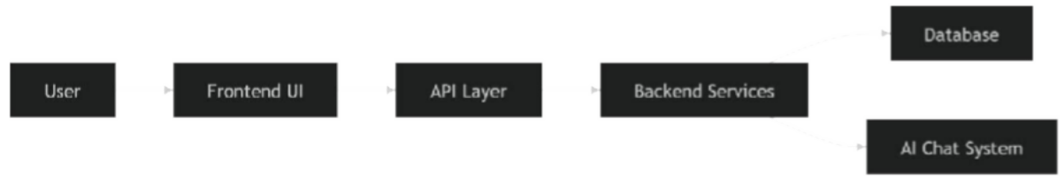

Figure 3 Functional Block Diagram
Description:

The system begins with the user interacting with the frontend interface. The UI communicates with backend services through APIs. The backend processes requests and retrieves data from the database or AI module.
This structure ensures modularity and scalability.

System Flow Chart
The system flow chart illustrates the step-by-step operation of the application.
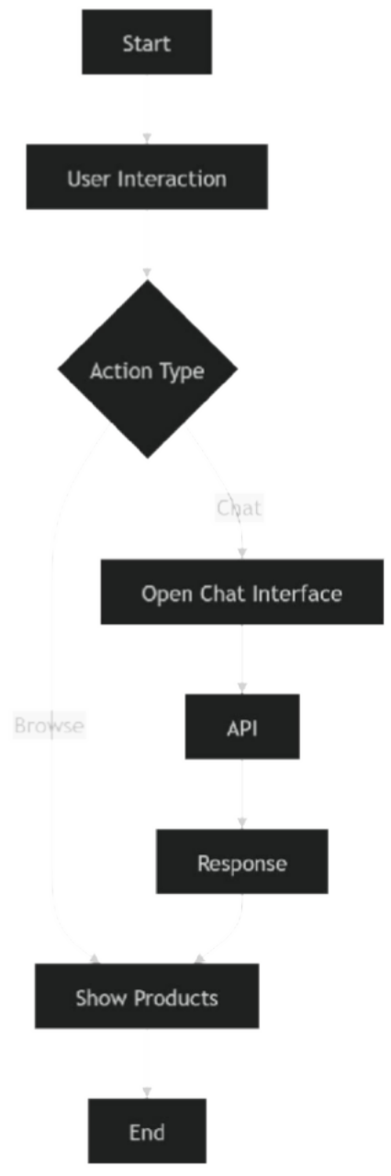

Figure 4 System Flow Chart

Description

The flow begins with user interaction. Depending on the action (browsing or chatting), the system processes requests and displays appropriate responses.

Choosing Devices (Adapted for Web System)
Although the template refers to hardware devices, in this project, the focus is on selecting appropriate software tools and platforms.

Table 5.2 Tool Comparison

Feature | React | Next.js | Vanilla JS
Architecture | Component-based | Framework-based | Script-based
Performance | High | Optimized | Moderate
Scalability | High | Very High | Low
Learning Curve | Medium | Medium | Low
Use Case | SPA | Full-stack apps | Basic sites

Selection Justification React was chosen due to:
Component-based architecture Strong ecosystem
Suitability for dynamic UI

Next.js exposure provided understanding of scalable frameworks.

Designing Units
The system was divided into functional units for modular development.

Units Identified: UI Components
Data Handling Unit Chat Interface Unit API Integration Unit
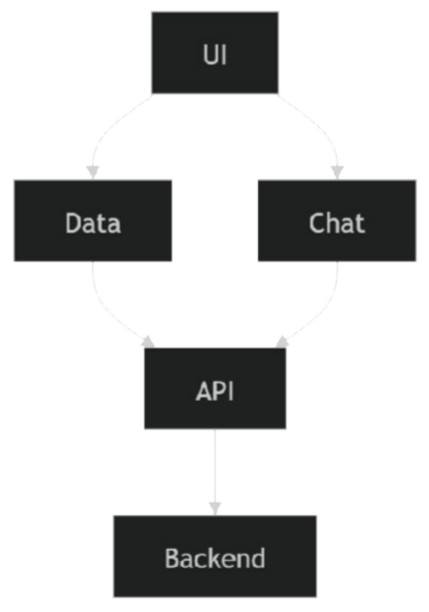

Figure 5 Unit Interaction Diagram
Description

Each unit operates independently but interacts through defined interfaces, ensuring modularity and ease of development.

Standards
Standards ensure interoperability, security, and efficiency in system design. Relevant Standards

Web Standards:

HTML5, CSS3, JavaScript Data Formats:
JSON

Communication Protocols:

HTTP/HTTPS

Security Standards:

Basic secure communication practices Benefits
Improved compatibility Enhanced scalability Better maintainability

Mapping with IoTWF Reference Model Layers (Adapted)
Even though this is not a traditional IoT system, the architecture can be mapped conceptually.

Table 5.3 IoTWF Mapping

Layer | Project Mapping | Security
Application | Web UI (React) | Input validation
Data Abstraction | API responses | Secure data handling
Data Accumulation | Database | Controlled access
Edge Computing | Backend logic | API validation
Connectivity | HTTP APIs | HTTPS
Physical Layer | User devices | Device-level security

Domain Model Specification
The domain model represents entities and relationships.
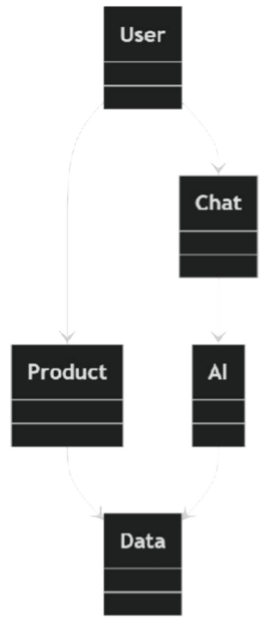

Figure 6 Domain Model Specification
Description

User interacts with products and chatbot Data is retrieved through backend systems AI module processes queries

Communication Model
The system primarily follows a Request-Response model.

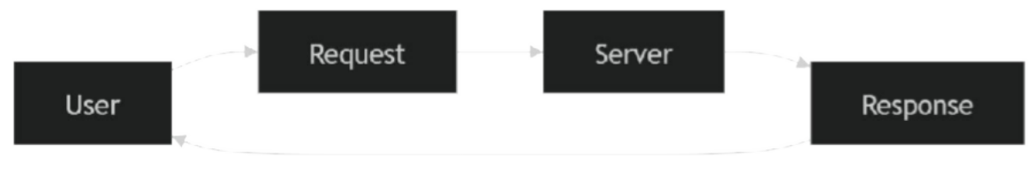

Figure 7 Communication Model
Justification:

Suitable for web applications Simple and efficient
Supports API-based communication

Deployment Level (Adapted)
The system follows a cloud-based deployment model: Frontend hosted on web server
Backend services accessed via APIs Scalable architecture

Functional View
The system can be divided into functional groups: UI Layer
Communication Layer Backend Services Data Layer
AI Layer

Mapping Deployment with Functional View
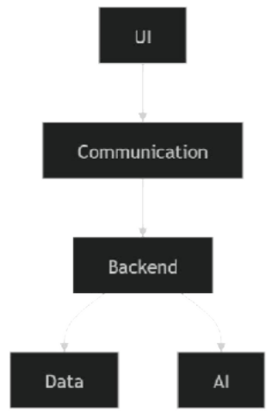

Figure 8 Functional View
Description

Each functional group corresponds to a deployment layer, ensuring structured operation.

Operational View
The operational view defines system behaviour: User interacts with UI
Requests sent via API Backend processes data Response displayed

Other Design Aspects
- Process Specification

- Input → Processing → Output

- Information Model

- Product data

- User interaction data

- Service Specification

- API-based services

- Chat interaction

Chapter 6

HARDWARE, SOFTWARE AND SIMULATION

Introduction
This chapter describes the hardware and software resources used during the internship, along with the implementation approach and testing procedures. Since the project was primarily focused on frontend web development, the emphasis is on software tools and development environments rather than specialized hardware systems.
The implementation was carried out in a local development environment with limited deployment, consistent with the early-stage nature of the startup.

Hardware Requirements
The project did not require specialized hardware, as development was carried out using a personal laptop.
    - System Specifications

Table 6.1 Hardware Specifications

Component | Specification
Processor | AMD Ryzen 7 6800H
GPU | RTX 3050 Laptop GPU
RAM | 16 GB
Storage | SSD
Display | 120 Hz

Hardware Suitability

The selected hardware was sufficient for:

Running development tools Rendering React applications Testing UI responsiveness
No additional hardware was required, making the setup cost-effective.

Software Requirements
The software stack used during the internship consisted of frontend technologies, development tools, and basic backend exposure tools.

    - Development Tools

Table 6.2 Development Tools

Tool | Purpose
Visual Studio Code | Code editor
Git | Version control
GitHub | Code repository
Browser DevTools | Debugging

    - Frontend Technologies

Table 6.3 Frontend Technologies

Technology | Purpose
HTML5 | Structure
CSS3 | Styling
JavaScript | Logic

Technology | Purpose
React | UI development

    - Design Tools

Table 6.4 Design Tools

Tool | Purpose
Figma | UI/UX design

Backend and AI Exposure Tools

Although backend development was not the primary responsibility, there was exposure to:

Table 6.5 Backend Tools

Tool | Purpose
FastAPI | Backend framework (observed)
REST APIs | Data communication
PDF Data | Knowledge input for AI

System Implementation
The system was implemented as a frontend web application using React. The development process focused on building reusable components and ensuring responsiveness.

Component-Based Implementation

The application was structured into reusable components. Example Components:

Navigation bar

Product display section Chat interface
Footer

This modular structure improved maintainability and scalability.

    - UI Development Approach Followed Figma design references Implemented layouts using CSS Ensured consistent styling

Responsive Design Implementation

Responsive design was implemented using:

CSS Flexbox CSS Grid Media queries
Testing was performed across different screen sizes.

Sample Code Representation
Due to confidentiality constraints, actual project code cannot be disclosed. However, representative code snippets are provided to illustrate the approach.

React Component Example

function ProductCard({ title, description }) {

return (

<div className="card">

<h2>{title}</h2>

<p>{description}</p>

</div>

);

}

    - API Fetch Example useEffect(() => { fetch('/api/products')
.then(response => response.json())

.then(data => setProducts(data));

}, []);

Chat UI Logic Example

function ChatBox() {

const [messages, setMessages] = useState([]);

const sendMessage = (msg) => { setMessages([...messages, msg]);
};

return (

<div>

{messages.map((m, i) => <p key={i}>{m}</p>)}

</div>

);

}

Simulation and Testing
Since the system is a web application, simulation refers to testing within a development environment.

Testing Methods

Manual UI testing

Responsive testing using browser tools Debugging using console and DevTools

    - Test Scenarios

Table 6.6 Test Cases

Test Case | Input | Expected Output | Result
UI Load | Open page | UI renders correctly | Pass
Responsiveness | Resize screen | Layout adapts | Pass
Chat UI | Enter message | Message displayed | Pass
API Fetch | Request data | Data displayed | Pass

    - Testing Challenges CSS layout inconsistencies React state handling issues
Debugging asynchronous operations

Limitations of Implementation
No full backend implementation AI chatbot not fully integrated Deployment not completed
These limitations are consistent with the scope of an internship project in a startup environment.

Summary
The implementation of the system was carried out using modern frontend technologies with a focus on modular design and responsiveness. The use of open-source tools ensured cost- effectiveness, while testing ensured functional correctness.
The system remains in a developmental stage, with scope for further enhancement in backend integration and AI functionality.

Chapter 7

EVALUATION AND RESULTS

Introduction
This chapter presents the evaluation of the developed system and the outcomes of the internship work. The evaluation focuses on testing the functionality, usability, and performance of the frontend application developed using React.
Since the project was developed in a startup environment and is still in a developmental stage, the evaluation is based on functional testing, user interface behavior, and system responsiveness rather than large-scale deployment metrics.

Evaluation Objectives
The primary objectives of evaluation were:

To verify the correctness of the user interface To ensure responsiveness across devices
To test integration with APIs

To validate the functionality of the chat interface To assess overall usability

Evaluation Criteria
The system was evaluated based on the following parameters:

    - Functional Correctness Proper rendering of UI components Correct handling of user interactions

Usability

Ease of navigation

Clarity of interface Accessibility of information

Performance

Load time of UI

Smooth transitions between components

    - Responsiveness Adaptability across devices Layout consistency
    - Maintainability Reusability of components Clean code structure

Testing Strategy
Testing was primarily conducted through manual methods, as the project did not involve automated testing frameworks.

Types of Testing Performed

Unit-Level Testing (UI Components)

Testing individual components for correct rendering Integration Testing
Verifying interaction between UI and APIs Responsive Testing
Checking layout behavior on different screen sizes User Interaction Testing
Ensuring correct response to user inputs

Test Results
Table 7.1 Test Results Summary

Test Case | Description | Expected Result | Outcome
UI Rendering | Load main page | Components display correctly | Pass
Navigation | Switch sections | Smooth transitions | Pass
Responsiveness | Resize screen | Layout adapts | Pass
API Integration | Fetch data | Data displayed | Pass
Chat UI | Send message | Message shown | Pass

Observations
During testing and usage, the following observations were made: The UI components functioned as expected
Navigation between sections was smooth The system was responsive across devices
API integration worked for basic data handling The chat interface was functional at the UI level However:
Backend-dependent features were limited

AI chatbot functionality was not fully integrated Performance optimization can be improved

Performance Analysis
The system performed adequately for a frontend prototype.

Key Performance Points:

Fast rendering due to React’s virtual DOM Minimal lag in navigation
Efficient handling of component updates Limitations:
No performance benchmarking tools used No stress testing under heavy load
Dependent on backend performance for full functionality

Learning Outcomes
One of the most important aspects of this internship was the learning experience.

Technical Learning

Improved understanding of React Learned component-based architecture Gained experience in responsive design Understood API integration basics

Practical Learning

Exposure to real-world development workflow Experience in debugging and fixing issues Understanding of collaborative development

Conceptual Learning

Basic understanding of backend systems

Exposure to AI-based systems (RAG concepts) Understanding system architecture

Challenges and How They Were Addressed
Challenge 1: React Complexity

Difficulty in understanding state and component behavior Solution: Practice and documentation reference

Challenge 2: CSS Responsiveness Layout issues across devices
Solution: Use of Flexbox, Grid, and testing

Challenge 3: Debugging Issues Unexpected UI behavior
Solution: Developer tools and iterative fixes

Challenge 4: Startup Workflow Lack of structured process
Solution: Adaptability and communication

Limitations of the Project
Backend not fully implemented AI chatbot partially developed No full deployment

Limited testing scope

These limitations are expected given the scope of an internship project and the startup environment.

Key Insights
Frontend development requires strong understanding of UI/UX principles React simplifies complex UI development but has a learning curve Responsive design is critical but challenging
Real-world projects involve continuous learning and adaptation Collaboration is essential even for frontend tasks

Summary of Results
The project successfully achieved its primary goals of developing a responsive frontend interface and demonstrating integration capabilities.
Key outcomes include:

Functional and responsive UI Modular component structure Basic API integration
Working chat interface (UI level) Improved technical and practical skills
The results indicate that the project provides a strong foundation for further development and integration.

Chapter 8

SOCIAL, LEGAL, ETHICAL, SUSTAINABILITY AND SAFETY

Introduction
This chapter discusses the broader implications of the developed system beyond its technical aspects. It examines how the project impacts society, complies with legal frameworks, adheres to ethical principles, supports sustainability goals, and ensures safety in its usage.
Since the project is associated with a startup operating in the sustainable energy domain, these aspects are particularly relevant.

Social Aspects
The development of a digital platform for a sustainable energy startup contributes positively to society in several ways.

Accessibility of Information

The platform improves access to information about renewable energy solutions such as solar panels and EV charging systems. Users can explore these technologies without requiring direct interaction with the company.
This helps:

Increase awareness of sustainable technologies Educate users about eco-friendly solutions

Improved Customer Interaction

The inclusion of a chat interface enhances communication between users and the organization. Benefits include:
Faster query resolution

Reduced dependency on manual communication Improved user experience

Digital Inclusion

      - By providing an online platform, the system enables wider reach, allowing users from different regions to access services.
      - However, limitations exist:

      - Users with low digital literacy may face challenges

      - Internet access is required

Impact on Startup Growth

      - The digital platform supports the growth of the startup by:

      - Improving visibility

      - Enhancing customer engagement

      - Enabling scalability

      - This contributes indirectly to economic development.

Legal Aspects
Legal considerations are essential in developing any digital system, even at a prototype level.

Data Privacy

Although the current system does not handle sensitive user data extensively, basic privacy principles must be followed:
      - Avoid unnecessary data collection

      - Ensure secure handling of user inputs

      - Prevent data misuse

Compliance with IT Laws

The system must comply with applicable IT regulations, including: Proper use of user data
Avoidance of misleading information Transparency in communication

Intellectual Property

Code developed during the internship may belong to the organization Use of open-source tools must follow licensing rules

Ethical Aspects
Ethical considerations ensure that the system is used responsibly and does not negatively impact users.

Transparency

The platform should provide accurate and clear information about products and services. Misrepresentation can lead to loss of trust.

Responsible Use of AI

Since the system includes a chatbot interface with potential AI integration: Responses should be reliable

Users should not be misled by incorrect information AI limitations should be acknowledged

User-Centric Design

The system should prioritize user needs:

Easy navigation Clear content Accessible interface

Avoiding Bias

AI systems should not produce biased or misleading responses. Although full AI implementation is not completed, this remains an important consideration for future development.

Sustainability Aspects
Sustainability is a core theme of the project, both in terms of the company’s domain and the digital system itself.

Promotion of Green Technologies

The platform promotes:

Solar energy

EV charging infrastructure Water treatment systems
This supports environmentally friendly practices.

Reduction of Physical Resources

Digital platforms reduce the need for:

Printed materials Physical marketing
This contributes to resource conservation.

Energy Efficiency

Although web applications consume energy, efficient frontend design can minimize resource usage.

Alignment with Sustainable Development Goals

The project contributes to:

Clean energy adoption Sustainable infrastructure Environmental awareness

Safety Aspects
Safety considerations ensure that the system operates securely and reliably.

    - System Safety Avoid crashes and errors Ensure stable UI behavior

Data Safety

Prevent unauthorized access

Avoid exposure of sensitive data

User Safety

Provide clear and accurate information Avoid misleading content

Future Safety Considerations

Secure API integration AI response validation Protection against misuse

Summary
The project demonstrates positive social impact by improving access to sustainable technologies and enhancing user interaction. Legal and ethical considerations have been acknowledged, ensuring responsible system development.
The system also aligns with sustainability goals by promoting eco-friendly solutions and reducing reliance on physical resources. Safety considerations have been incorporated to ensure reliable and secure operation.
Overall, the project reflects a balanced approach that integrates technical development with broader societal and ethical responsibilities.

Chapter 9

CONCLUSION AND FUTURE SCOPE

Conclusion
The internship at Raghuraj provided a valuable opportunity to gain practical experience in frontend web development within a real-world startup environment. The primary objective of the internship was to contribute to the development of a digital platform that could support the company’s transition toward an online presence.
During the course of the internship, a responsive frontend system was developed using modern technologies such as React. The system was designed to present the company’s products and services in a structured and accessible manner. The implementation included reusable UI components, responsive layouts, and a basic chat interface that can be extended for AI-based functionality.
The project successfully demonstrated the use of component-based architecture for building scalable user interfaces. It also highlighted the importance of responsive design in ensuring accessibility across devices. Basic integration with APIs was achieved, enabling dynamic content handling within the application.
In addition to technical contributions, the internship provided exposure to real-world development practices. Working in a startup environment required adaptability, as workflows were flexible and requirements evolved over time. This experience helped in understanding how software systems are developed incrementally rather than in a strictly predefined manner.
The internship also offered insight into backend systems and AI-based applications. Although the primary role was frontend development, exposure to API workflows, backend structures, and concepts such as Retrieval-Augmented Generation (RAG) contributed to a broader understanding of full-stack systems.
Several challenges were encountered during the internship, including understanding React concepts, managing CSS responsiveness, and debugging issues. These challenges were addressed through continuous learning, practice, and iterative problem-solving.
Overall, the project achieved its primary goals and provided a strong foundation for further development. The experience gained during the internship has significantly contributed to both technical skills and practical understanding of software development.

Future Scope
While the current system provides a functional frontend prototype, there are several areas for future improvement and expansion.

Full Backend Integration

The current implementation includes only basic API interaction. Future development can include:
Complete backend system integration Database connectivity
Secure data handling

This will enable the system to function as a fully operational application.

Advanced AI Chatbot Implementation

The chat interface developed during the internship can be extended into a fully functional AI chatbot.
Future improvements include:

Integration with AI models

Implementation of Retrieval-Augmented Generation (RAG) Improved response accuracy
This will enhance user interaction and automate customer support.

Deployment and Hosting

The system can be deployed on cloud platforms such as: Vercel

Netlify

Deployment will make the application accessible to real users and allow further testing and improvement.

Performance Optimization

Future work can focus on:

Reducing load times

Optimizing component rendering Improving API response handling
This will enhance overall system performance.

Enhanced UI/UX Design

Further improvements in design can include: Advanced animations
Improved navigation

Better accessibility features

This will improve user engagement.

Scalability and Feature Expansion

The system can be expanded to include:

User accounts

Product filtering and search Real-time data updates
These features will make the platform more comprehensive.

Security Enhancements

Future development should include:

Secure API communication Authentication mechanisms Data protection measures
This is essential for production-level deployment.

Final Remarks
The internship served as an important step in transitioning from theoretical knowledge to practical application. It provided a deeper understanding of frontend development, system design, and real-world software workflows.
The experience also highlighted the importance of continuous learning and adaptability in the field of technology. Working in a startup environment offered valuable insights into how systems evolve over time and how collaborative efforts contribute to successful project development.
The knowledge and skills gained during this internship will be beneficial for future academic and professional pursuits in software development.

REFERENCES
- International Energy Agency (2023) Renewables Report. Available at: https://www.iea.org (Accessed: 9 April 2026).
- Statista (2024) Digital Consumer Behaviour Statistics. Available at: https://www.statista.com (Accessed: 9 April 2026).
- Nielsen, J. (1994) Usability Engineering. San Francisco: Morgan Kaufmann.

- React (2024) React Documentation. Available at: https://react.dev (Accessed: 9 April 2026).
- Next.js (2024) Next.js Documentation. Available at: https://nextjs.org (Accessed: 9 April 2026).
- Figma (2024) Figma Documentation. Available at: https://www.figma.com (Accessed: 9 April 2026).
- United Nations (2023) Sustainable Development Goals Report. Available at: https://sdgs.un.org (Accessed: 9 April 2026).
- Krug, S. (2014) Don’t Make Me Think: A Common Sense Approach to Web Usability. 3rd edn. Berkeley: New Riders.
- Fielding, R.T. (2000) Architectural Styles and the Design of Network-based Software Architectures. PhD Thesis. University of California, Irvine.
- Chen, J. et al. (2023) ‘Retrieval-Augmented Generation for Knowledge-Intensive NLP Tasks’, arXiv preprint arXiv:2005.11401.
- Perez, F. and Granger, B.E. (2007) ‘IPython: A System for Interactive Scientific Computing’, Computing in Science & Engineering, 9(3), pp. 21–29.
- Pressman, R.S. and Maxim, B.R. (2019) Software Engineering: A Practitioner’s Approach. 9th edn. New York: McGraw-Hill.
- Gamma, E., Helm, R., Johnson, R. and Vlissides, J. (1994) Design Patterns: Elements of Reusable Object-Oriented Software. Boston: Addison-Wesley.
- Mozilla Developer Network (2024) Web Development Documentation. Available at: https://developer.mozilla.org (Accessed: 9 April 2026).

- Git (2024) Git Documentation. Available at: https://git-scm.com/docs (Accessed: 9 April 2026).
- FastAPI (2024) FastAPI Documentation. Available at: https://fastapi.tiangolo.com (Accessed: 9 April 2026).
- Raghuraj (2025) Internal Company Data and Internship Materials.

APPENDIX—A

System Configuration
This appendix outlines the system configuration and technologies used for developing the AI- powered chatbot system.

Model Used: GPT-4 / Gemini Framework: LangChain Backend: FastAPI Frontend: React
Vector Database: ChromaDB

Embedding Model: OpenAI Embeddings / Gemini Embeddings Programming Language: Python
Environment: Virtual Environment (venv) Dependency Management: requirements.txt Configuration File: params.yaml

APPENDIX—B

Query Processing Workflow
This appendix describes the step-by-step workflow followed by the system to process user queries and generate responses.

- The user enters a query through the frontend interface.

- The query is sent to the backend API.

- The backend processes the query and converts it into embeddings.

- Relevant documents are retrieved from the vector database using similarity search.

- Retrieved context is combined with the user query.

- The combined input is passed to the Large Language Model.

- The model generates a response based on the context.

- The response is returned to the frontend and displayed to the user.

APPENDIX—C

Project Directory Structure
This appendix presents the modular directory structure of the chatbot system, highlighting the organization of various components.

Root Directory:

- data/ : Stores raw and processed datasets
- models/ : Contains trained or saved models
- src/ : Core application source code
  - api/ : Handles API endpoints and routing
  - chains/ : Implements LangChain pipelines
  - chatbot/ : Core chatbot logic and interaction handling
  - config/ : Configuration settings
  - embeddings/ : Embedding generation logic
  - ingestion/ : Data ingestion pipeline
  - loaders/ : Custom data loaders
  - preprocessing/ : Data cleaning and preprocessing
  - vector_store/ : Vector database handling
- eval.py : Model evaluation script
- train.py : Training pipeline
- preprocess.py : Data preprocessing script
- params.yaml : Configuration parameters
- requirements.txt : Project dependencies
- README.md : Project documentation

